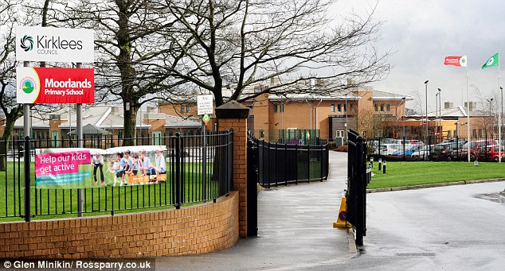**The Moorlands Primary School 2019 Calendar!**

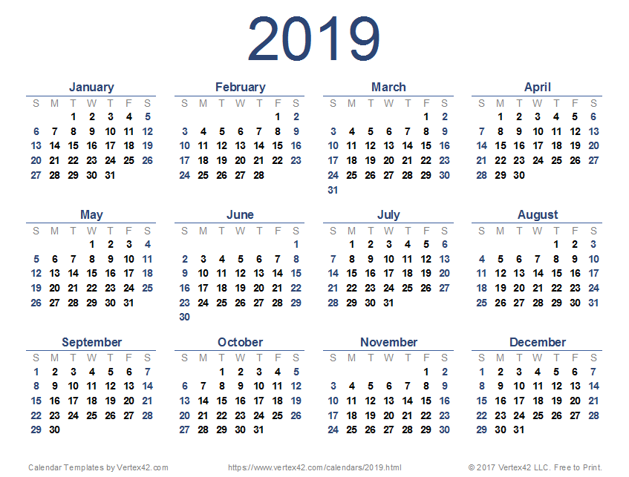

We have had an amazing year in 2018. With two Creative arts performances, four Christmas productions, a new lunch menu and loads of school trips Moorlands is a great school!

Moorlands Primary School is an amazing school in Outlane, Kirklees. Our motto is “High Expectations, High achievements, challenge and enjoyment for all.

