Week commencing  ^{15th} June | Topic
Day 1 | EAD:  Using junk modelling could you make your own castle? What do you need in your castle? Can you describe each part? You could google different castles and look at what they have or look at the pictures provided. If you don’t have any junk modelling you could draw and design, your own castle on paper or using the template provided.  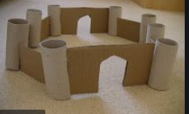  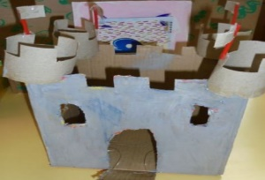  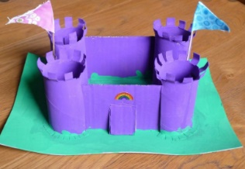
Day 2 | CCL/UTW/T  In fairy tale books we find many different characters. Can you think of the different characters, kings, queens, princesses, fairies, knights ect.  Can you use the internet to find out about real kinds, queens, princesses and princes? Who are they? Where do they live? What do they live in? How do they live? Are they similar to the characters we read in fairy tales?
Day 3 | PSED:  Choose a character either Cinderella or Aladdin. Do you think they were treated fairly? What happened to them? How do you think they feel? How should we treat people? Can you write a list or draw a picture to show how we should treat our friends and families?  PD:  Fairy tale yoga:  https://www.youtube.com/watch?v=7NWzS2xziI4&list=PLPOqSFjuZxwwrv6Wm-TIvrV9-KhzPfCPW
Day 4 | PD/Literacy:  Can you practise reading and writing the tricky words?  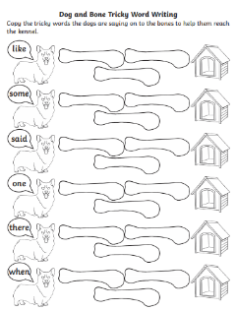  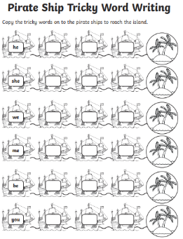  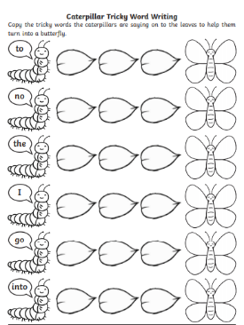
Day 5 | 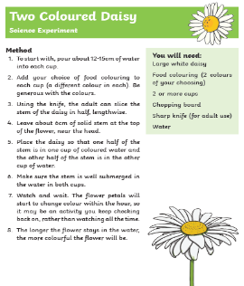  UTW:  Can you have a go at the daisy science experiment? What happens? Can you record the results?

We would love to receive any pictures of work, photos, videos either by email or uploaded to Early Essence.
Any questions please feel free to contact your class teacher on the email addresses below – teachers will be regularly checking emails.
DD@moorlandsprimary.org.uk SS@moorlandsprimary.org.uk
HH@moorlandsprimary.org.uk
If you would like to speak to your class teacher, then please email them your preferred contact number and they will happily call you for a catch up and to support with any activities.

