How Many?
Have a look at this photo of some peaches:
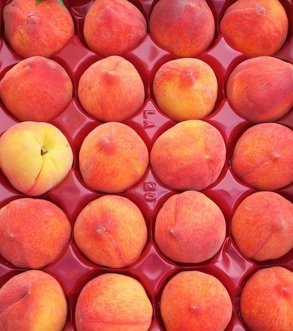
How many?
How did you count them?
Now take a look at this picture of oranges:
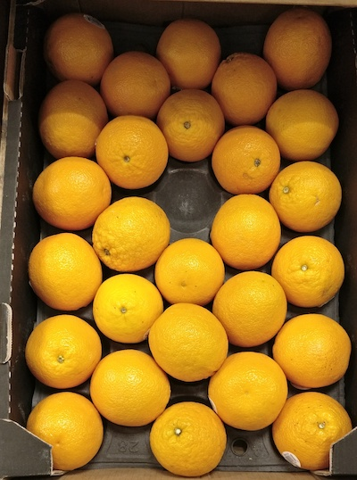
How many?
How did you count them?

And one last photo:
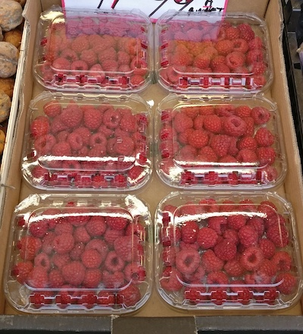
How many this time?
How did you count?

