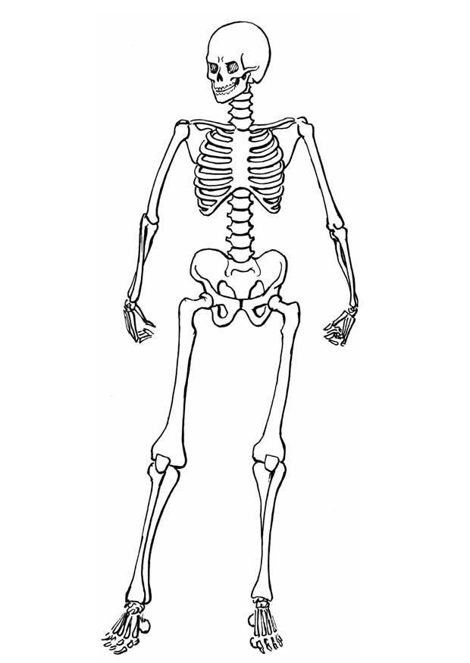
Can I label some parts of the human skeleton?

