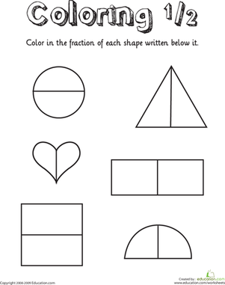
vvvvcv
Can you colour in half of the shape?

