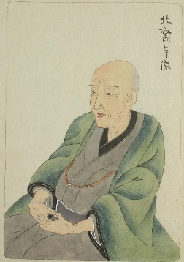
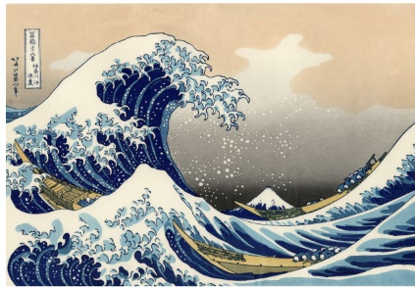
Art Project – Summer A
The Great Wave
Katsushika Hokusai
Japanese artist
Objectives:
- Your aim is to develop your appreciation of art and skills in drawing sections from the picture.
- We will be looking at seascapes art work - The Great Wave Off Kanagawa and research to learn some background to the piece.
- You will also learn about the geography of the piece and the artist.
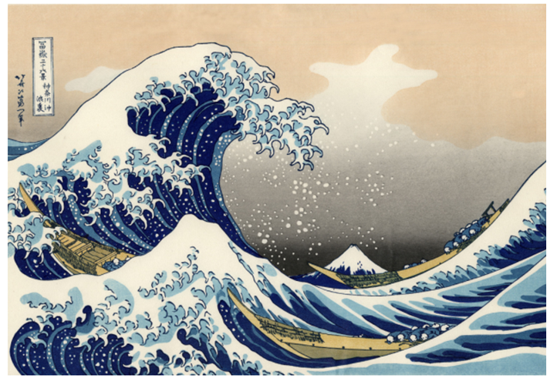

- What do you think is happening? Why do you think it is happening?
- Can you spot Mount Fuji?
- Can you find the boats?

The Great Wave off Kanagawa
- Can you use your research skills to find our more about this piece of artwork and also the artist – Hokusai?
- Here are some links below to get you started!
https://kids.kiddle.co/The_Great_Wave_off_Kanagawa
https://kids.kiddle.co/Katsushika_Hokusai
*You could also use YouTube videos to research!

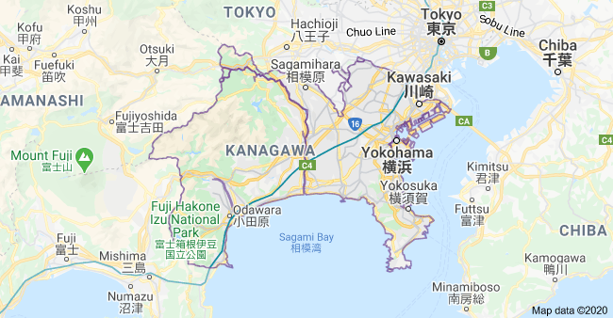
Geography-Where is Kanagawa?

Can you use Google Earth/Maps to find out more about the geography of Kanagawa?
*Remember there is the option to zoom in and out of the map and also to look at pictures of the
place!

- Kanagawa is a relatively small prefecture wedged between Tokyo on the north, the foothills of Mount Fuji on the northwest, and the Pacific Ocean and Tokyo Bay on the south and east.
- The eastern side of the prefecture is relatively flat and heavily urbanized, including the large port cities of Yokohama and Kawasaki, but becomes more relaxed to the southeast, near the Miura Peninsula, where the ancient city of Kamakura draws tourists to its temples and shrines.
- The Tama River forms much of the boundary between Kanagawa and Tokyo. The Sagami River flows through the middle of the prefecture.

More information
- The Great Wave off Kanagawa
- The Great Wave off Kanagawa is a famous woodblock printing by the Japanese artist Hokusai. A literal translation of the Japanese name would be "Off Kanagawa, the back (or underside) of a wave." It was published in 1832 as the first in Hokusai's series 36 Views of Mount Fuji and is his most famous work. It depicts an enormous wave threatening boats near the Japanese of Kanagawa; Mount Fuji can be seen in the background. The wave is probably not intended to be a tsunami , but a normal ocean wave created by the wind. Like the other prints in the series, it depicts the area around Mount Fuji under particular conditions.
- Copies of the print hang at the Metropolitan Museum of Art in New York City, the British Museum in London, and in Claude Monet Monets house in Giverny, France.
- The logo for the surf brand Quiksilver is based upon this artwork.
Can you use google to see different interpretations of this picture?
Your task – Sketch and colour ‘The Great Wave’

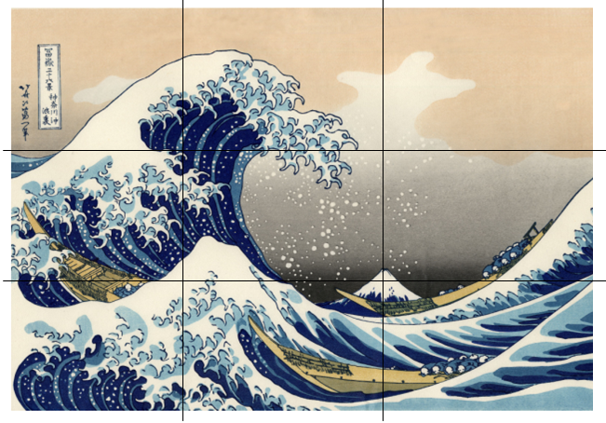
Steps to success:
- You should split your piece of A4 paper into 9 equal boxes (like the completed example picture). You should use a ruler and pencil to do this.
*Who could you ask to help you? Remember, you can always email your teacher for more help with this!
- You should focus on sketching one area of the picture using your frame and sketch it larger scale. This should not be rushed!
- When you have sketched your picture, use coloured pencil crayons to complete your piece of artwork.
*Your teacher would love to see a picture of your piece of artwork!

